Mission 1

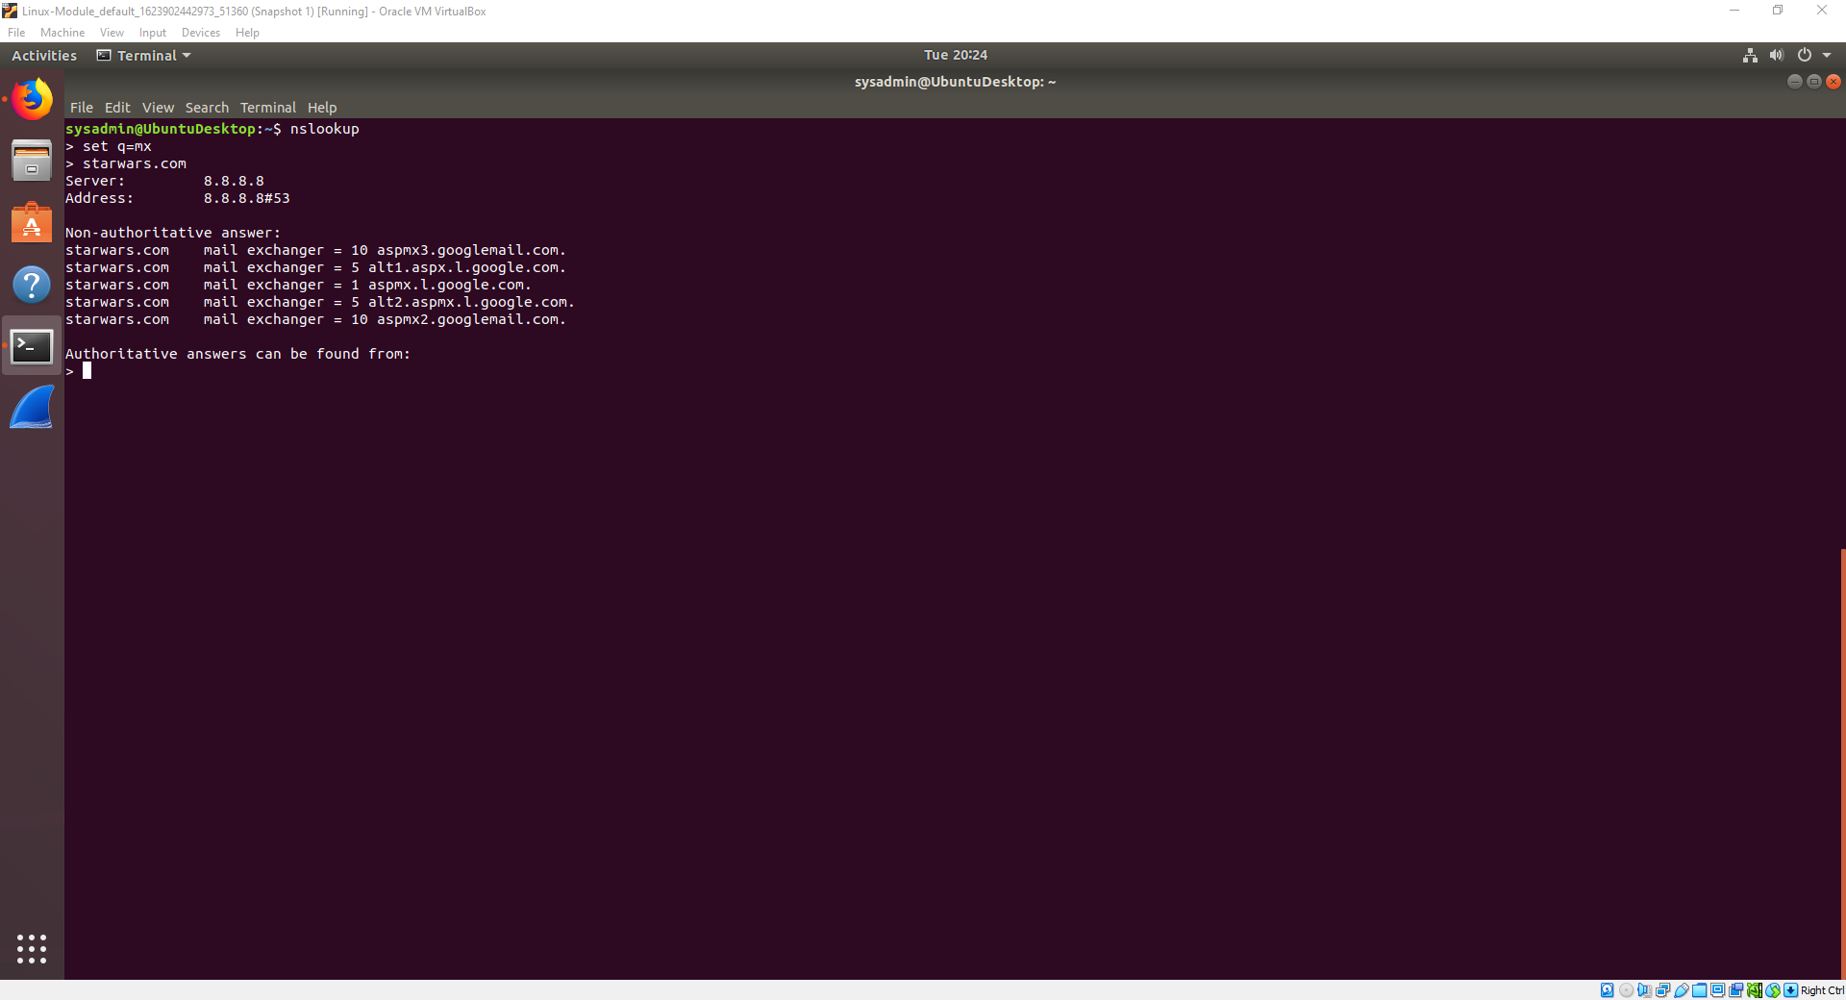

* The emails are not set up correctly asltx.l.google.com and the secondary should be asltx.2.google.com.
* Mail exchanger = 1 asltx.1.google.com
* Mail exchanger = 5 asltx.2.google.com

Mission 2

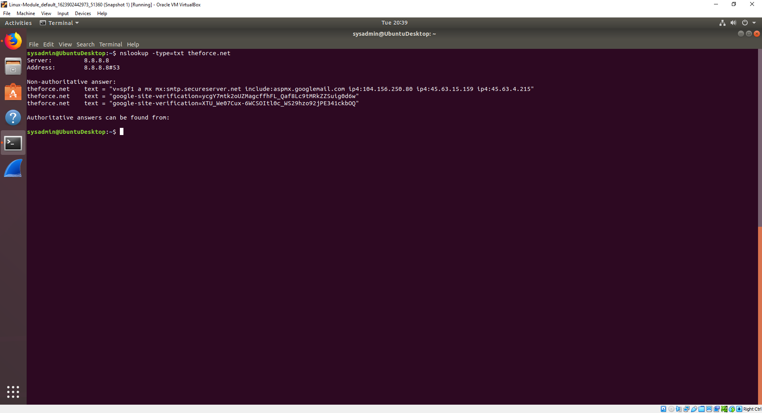

* 45.23.176.21 isn’t recognized as a trusted IP and is automatically sent to spam.
* v=spf1 a mx mx:smtp.secureserver.net include:aspmx.googlemail.com ip4:104.156.250.80 ip4:45.63.15.159 ip4:45.63.4.215 ip4: 45.23.176.21

Mission 3

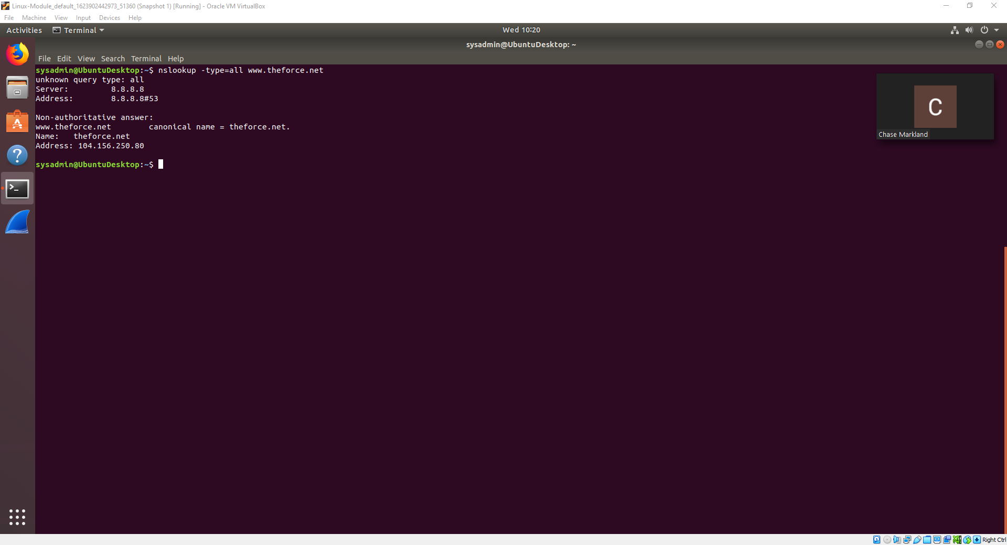

* Resistance.theforce.net has no record for the canonical name.
* resistance.theforce.net canonical name = theforce.net

Mission 4

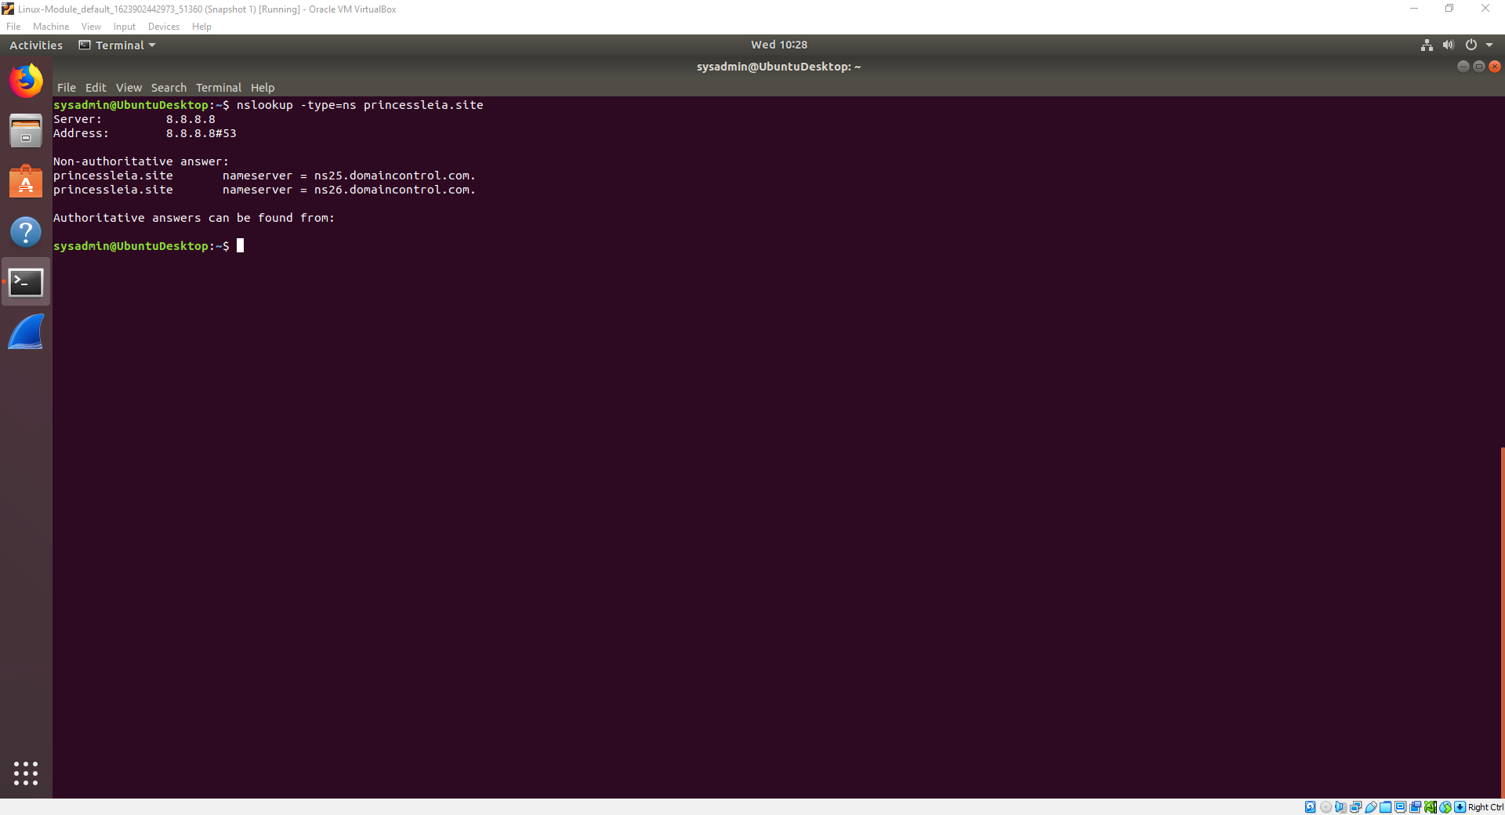

* nameserver = ns2.galaxybackup.com

Mission 5

Battu - D - C - E - F - J - I - L - Q - T - V - Jedha

Mission 6

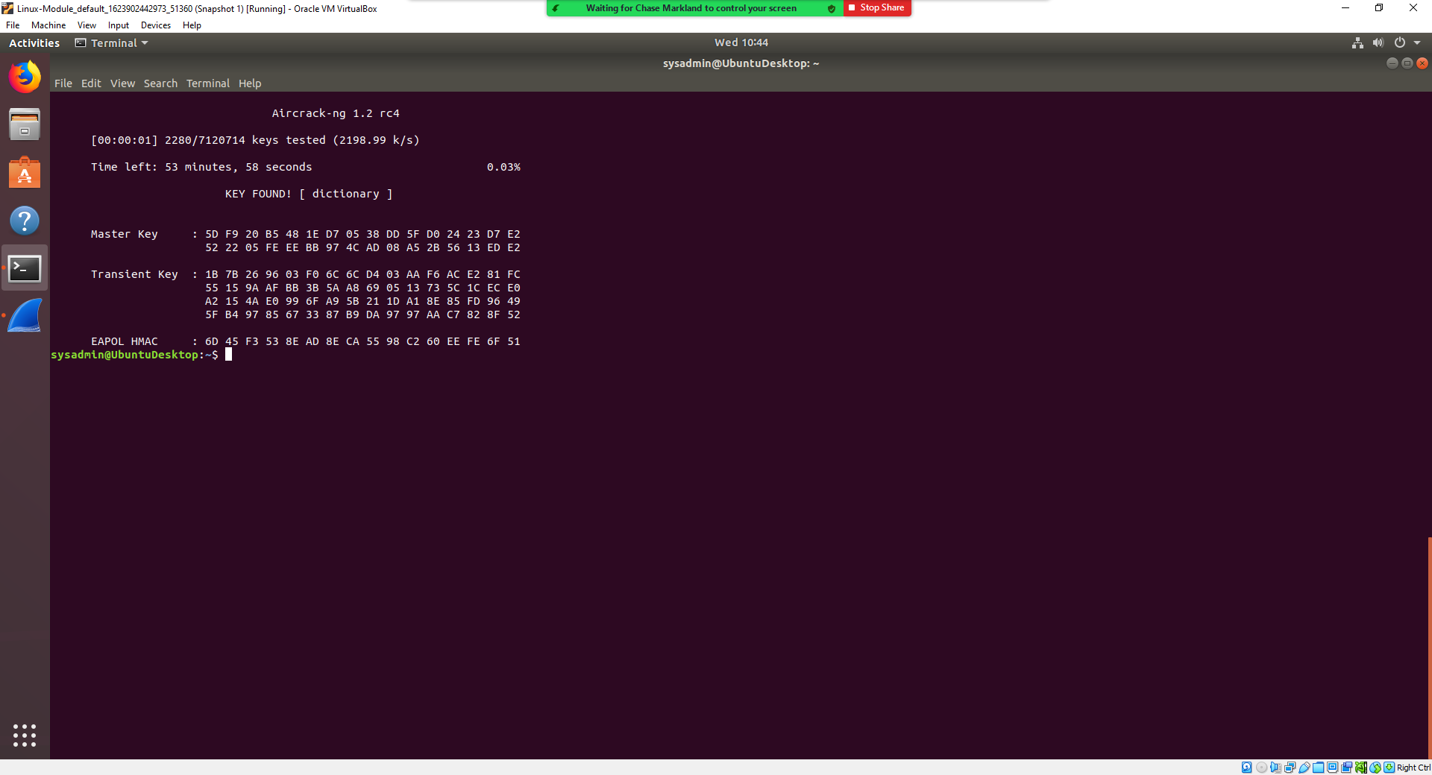

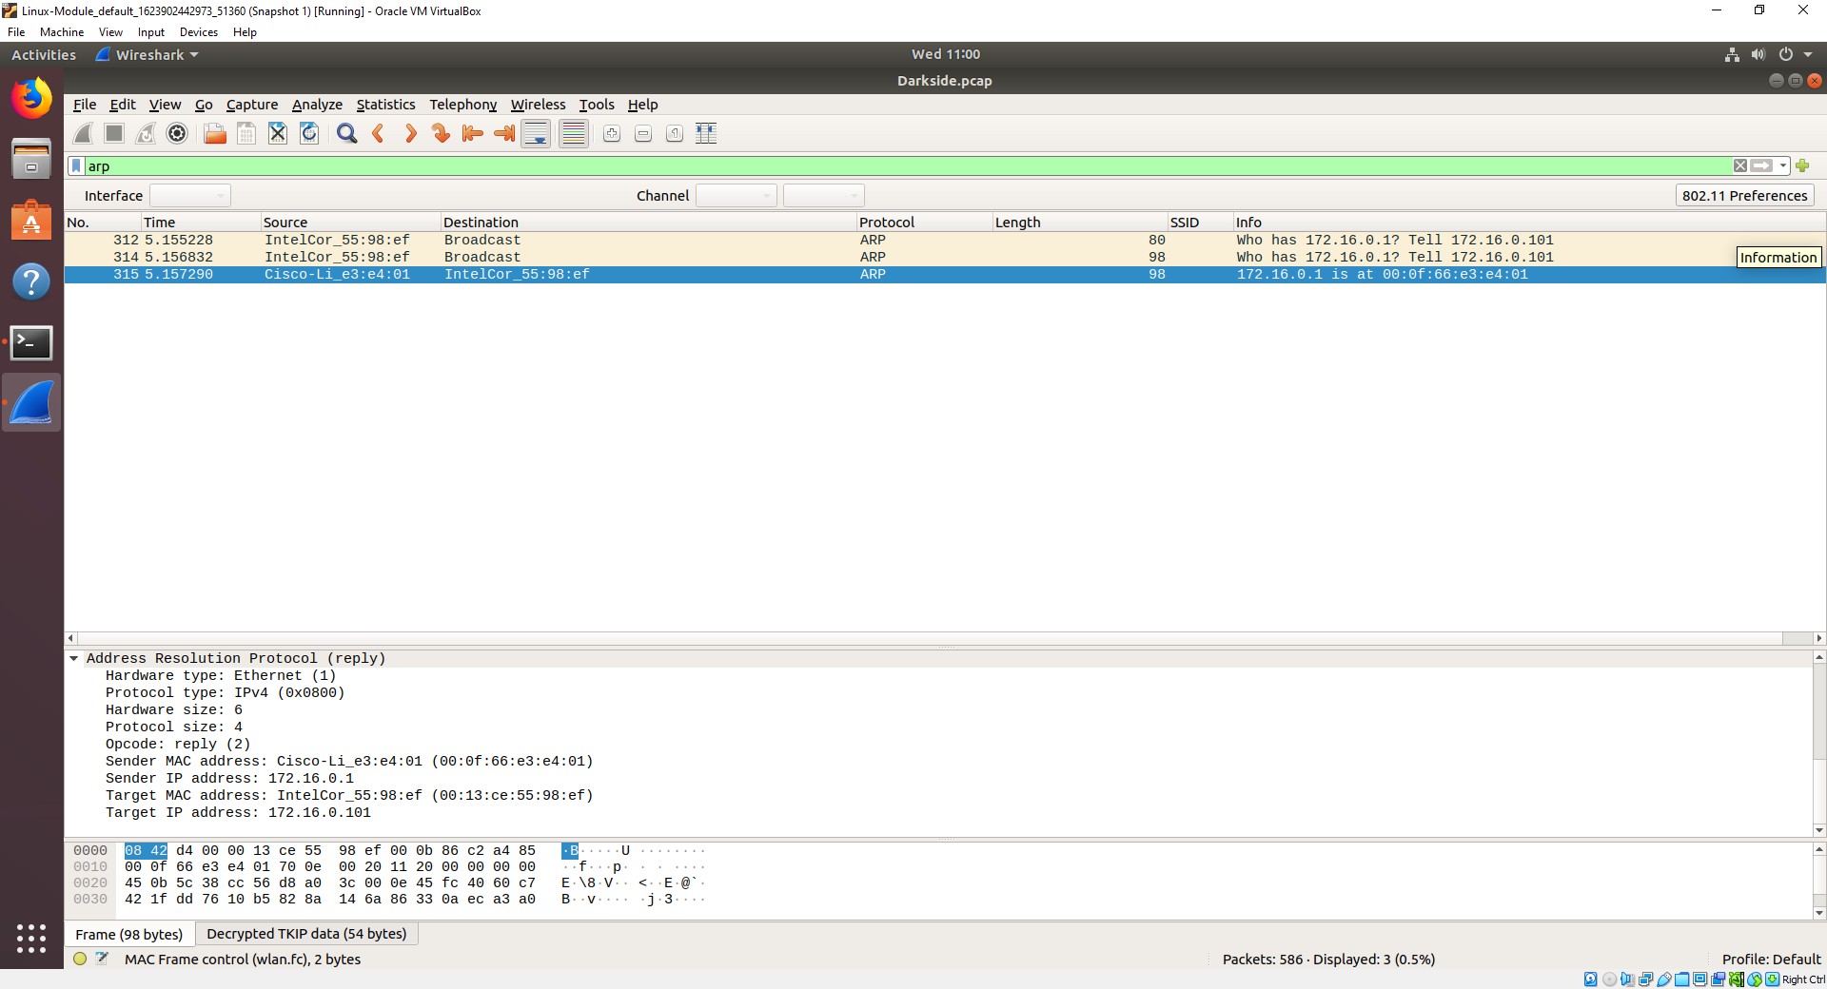

MAC: 00:0f:66:e3:e4:01 - IP: 172.16.0.1 MAC: 00:13:ce:55:98:ef - IP: 172.16.0.101

Mission 7

